4050 Group Algorithm Engineering Assignment

- Part III -

Cross-Paradigm Engineering Reflection
Isaac Dierker | Noah Pipes | Andrew W. Smith

Part 3.1 – Comparison of Divide-and-Conquer and Checking-Every-Pair in Inversion Counting
With Divide-and-Conquer, you can avoid comparing and checking every pair. This is because if an element on the right array is smaller than the smallest element in the left array (the current index checked), it must also be smaller than every other element left in the left array and can therefore count inversions as len(left_array)-left_index. This is much faster than what Checking-Every-Pair can do since checking every pair can only increment the inversion count by 1 per check. This allows Divide-and-Conquer to combine checks of pairs into one large check.
It is also clear that Divide-and-Conquer does less work than checking every pair. This is evident in the output we get from the terminal. In this specific run, at size 69, merge is already faster than brute force. It doesn’t necessarily happen at size 2 since merge has more overhead than brute force because of the recursive calls. But it is clear that Divide-and-Conquer beats with large n, which is what we care about, since the merge increase from doubling n was about 2.2 times, while brute force increased by about 3.7 times. At n=20,000, Divide-and-Conquer in this specific run was about 162.7 times faster than checking every pair.

Part 3.2 – Comparison of Recursive Subproblems Across Paradigms
The recursive subproblems in inversion counting is naturally independent since it doesn’t matter where there is an inversion in the inversion counting problem in order for the recursive to count it. If it exists, it will be counted at some point when combinging subarrays because of its nature. It doesn’t matter where in the chain that the inversion is counted since if there are m inversions and n inversions are counted before the final merge is done, then m-n inversions must be counted when doing the final merge since m-n elements are out of order.
The coin-changing problem works much differently than inversion counting because of the nature of the problem. Coin-changing recursive calls depend heavily on what the previous coin was. If the target is 12 and I have denominations 1,6,10, the optimal coins are 6, 6, but doing a basic greedy would say 10,1,1. Greedy is not able to keep track of how picking the largest coin would affect how the rest of the coins needed to make the optimal coin-change would change. In this case, the optimal amount of coins depends on the first coin chosen. If a 10 is chosen, then it can only take two 1’s to hit the target amount. But this answer changes if a 6 is chosen, since another 6 can be picked to give the answer 6,6. As each coin is chosen, the target amount changes.
This doesn’t happen in inversion counting since it doesn’t matter when an inversion is counted. An inversion just means that some numbers aren’t in order. So, putting parts of the array in order doesn’t change the total number of inversions that exist since those other numbers are still not in order yet and will be counted.

Part 3.3 – The Role of Sorting in the Divide-and-Conquer Improvement
Sorting in the divide-and-conquer is there to allow multiple inversions to be counted in one go vs one-by-one that pair-wise would give you. By sorting the array, the program knows that if the current element in the right array is less than the current element in the left array, it knows that it must also be less than every other element in the left array. This means that len(left_array)-left_index inversions can be counted by a single if statement where pair-wise would only allow you to incrememnt inversions by 1 if an inversion exists.

Part 3.4 – Differences in Runtimes with or without Memoization
The differences in the runtime of Naïve and Memoized are drastically different because Naïve relys on calling the Naïve function until it hits a base case and works its way back up. This means that the base cases are computed multiple times and that takes time that the computer doesn’t necessarily need to do if it were optimized. Memoized can avoid this because if Memoized has computed a value, that value becomes a base-case and prevents further recursive calls. This allows each state only needs to be calculated once using Memoization where Naïve would calculate it many times.
Specifically with our program, Naïve did 11,606 recurssive calls where Memoization did 168 recurssive calls. This was with a target value of 24 and denominations 1, 7, 8, 9, 15, 26, 41.
Here’s that specific terminal output.
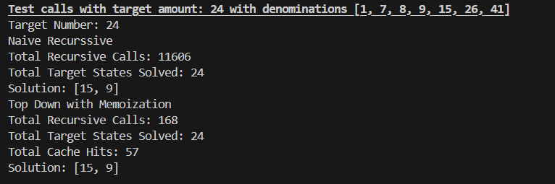

Part 3.5 – Utility of Baseline Implementations Across Paradigms
The baseline/exact implementations helped confirm that our faster algorithms were correct. Without the baseline implementation, the faster algorithms might’ve had a fatal flaw and were in agreement with that flaw so we would’ve never noticed that something was wrong with them. But by having an exact implementation and many small cases for it and the faster algorithms to run through, we were able to be confident that our faster algorithms work correctly.

Part 3.6 – Conclusions About Preference in Future Use of Paradigms
If I was given a new optimization problem, evidence that would help me chose Divide-and-Conquer would be evidence that subproblems are independent of each other. The fact that this is true allowed the Divide-and-Conquer algorithm to work for inversion counting and allowed for a much faster run-time than the brute force algorithm. Evidence that subproblems do depened on each other would make me want to solve it using dynamic programming since dynamic programming allows states that depend on each other to be solved. This is evident in the coin-changing problem where the current coin amount picked can heavily change the the coins picked in the sub-target amount.

